

**Placement Empowerment Program**

***Cloud Computing and DevOps Centre***

Use Cloud Storage Create a storage bucket on your cloud platform and upload/download files. Configure access permissions for the bucket.

**Name: Indhumathi S Department: CSE**



**Introduction:**

Cloud Storage is a scalable and secure solution for storing data in the cloud. It allows users to store and retrieve files such as images, videos, backups, and other types of data from anywhere. Cloud storage is commonly used for hosting static files, backups, and large datasets in cloud environments like **AWS S3 (Simple Storage Service**.A **storage bucket** is a logical container for storing objects (files) in the cloud. Configuring **access permissions** for the bucket ensures that only authorized users, applications, or services can upload, download, or modify files.

**Objective:**

**Understand cloud storage concepts** and how storage buckets work.

**Create a storage bucket** in a cloud platform (AWS, GCP, or Azure).

**Upload and download files** using both the cloud console and CLI.

**Configure permissions** to manage access control and security.

**Ensure data protection** by restricting or granting access based on policies.

**Step 1:**

Sign in to your cloud provider’s console:

**AWS**: Navigate to the S3 service

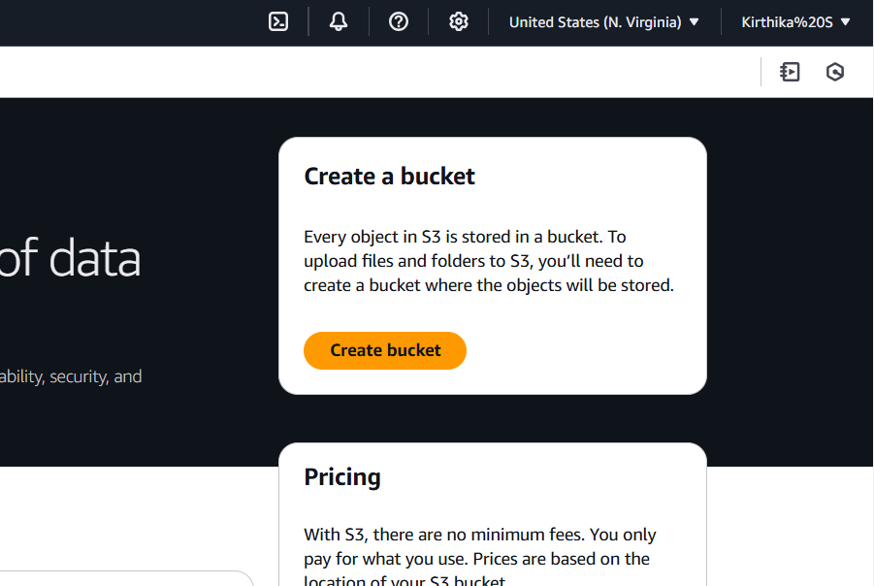

**Step 2:**

Create bucket with **unique name** and Leave other settings as default,

Configure **versioning** (optional) to keep previous versions of files.

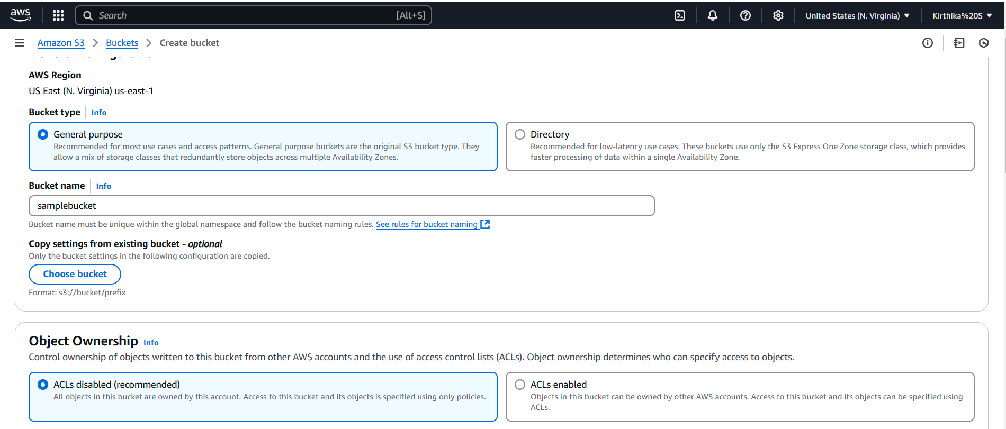

**Step 3:**

Bucket created,

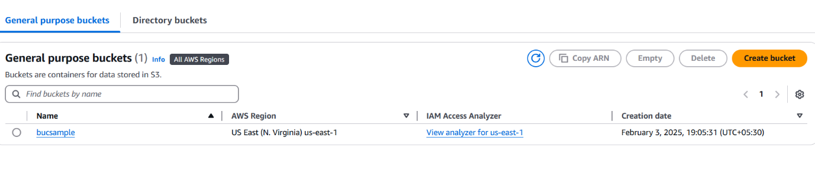**Step 4:**

Upload the files by click the Add new files, you can download the file

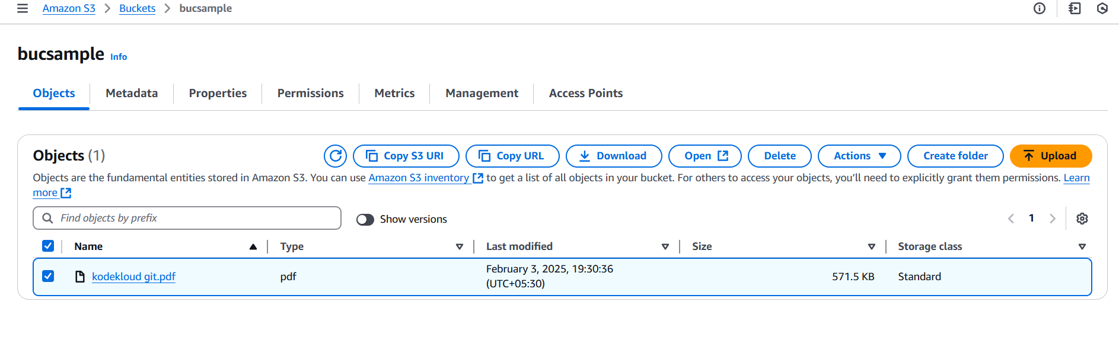

**Step 5:**

Go to the **Permissions** tab of your bucket

Enable the public access by clicking **edit option,** then click save changes

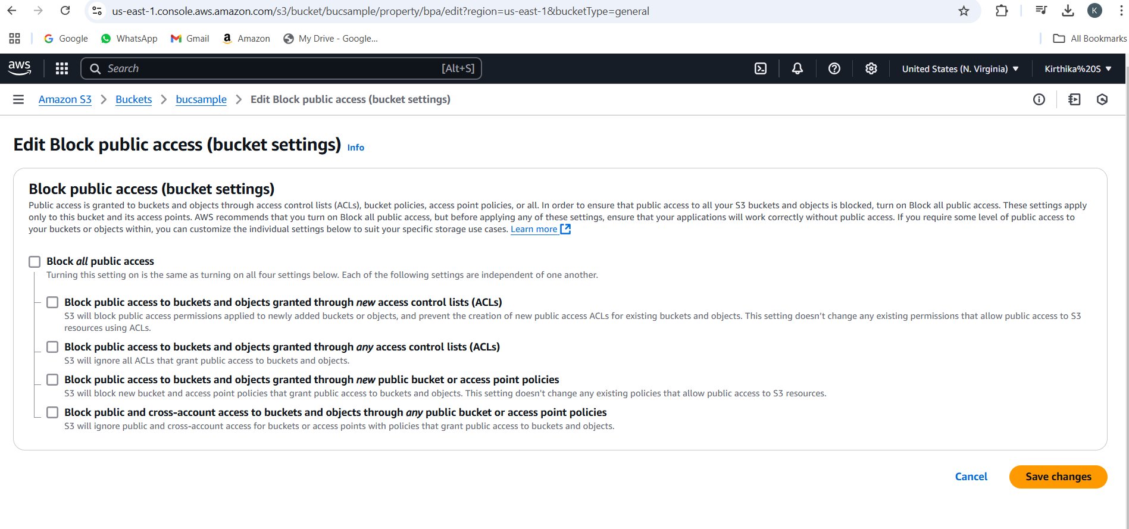

**Step 6:**

Scroll down to **Bucket Policy** and click Edit, you

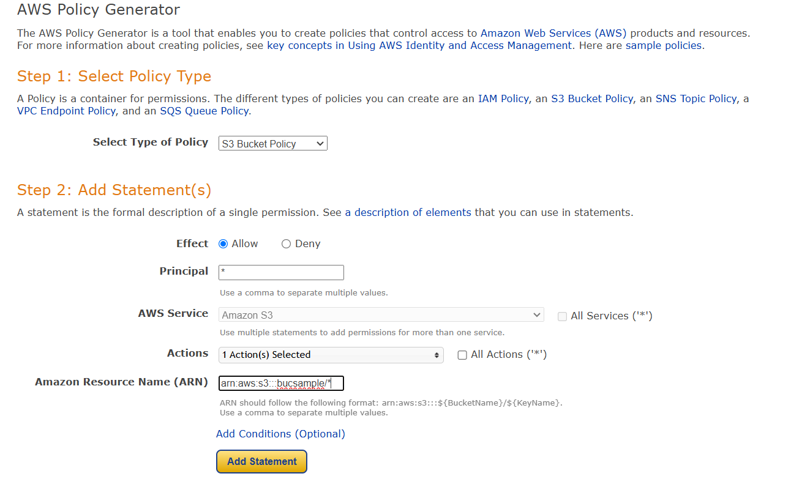

**Step 7:**

Save policy,

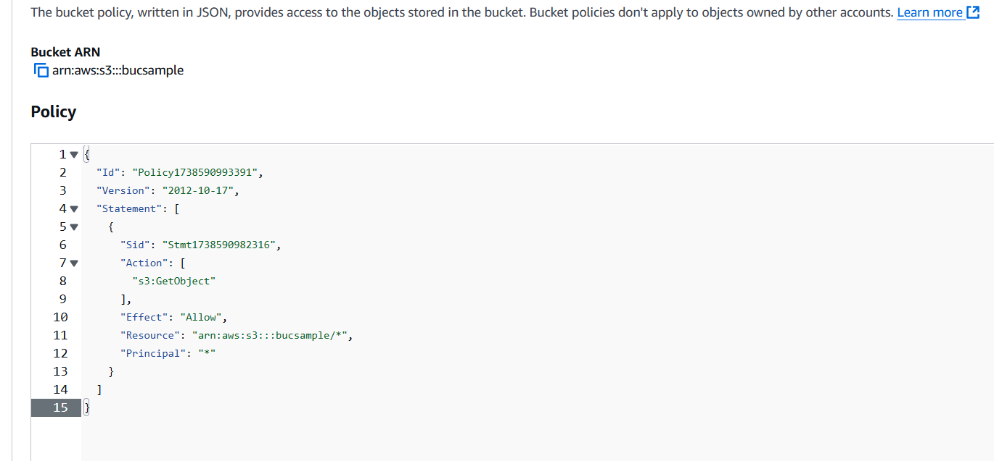

**Step 8:**

Copy the **Url** of your uploaded file in Copy URL option and paste it in the new web page

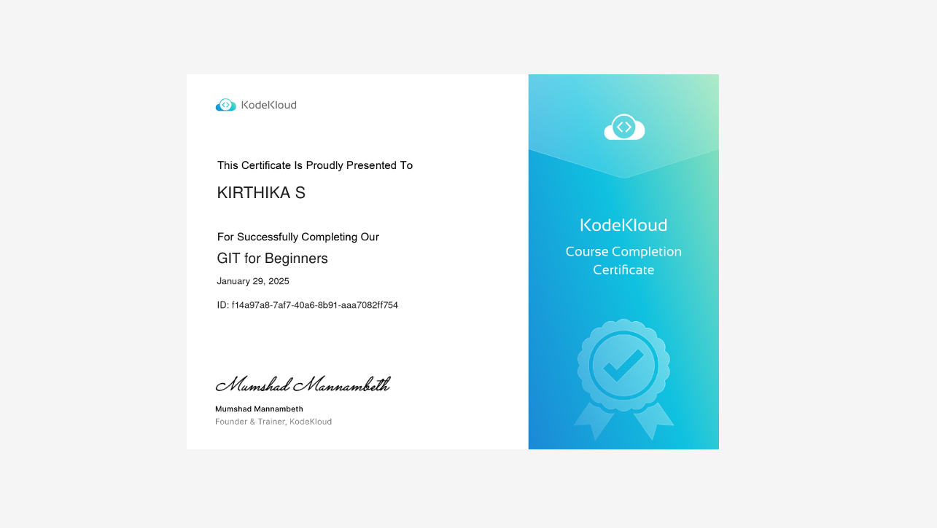

**Overview:**

✅ Created a **cloud storage bucket**.  
 ✅ Uploaded and downloaded files using the cloud console and command-line tools.  
 ✅ Configured **permissions** to control who can access the storage bucket.